Chemistry Test

Student’s Name
Author’s Affiliation
Course Number & Name
Instructor’s Name
Assignment Due Date

Chemistry Test
- If steel wool (Iron) is heated until it glows and placed in a bottle containing pure oxygen, the iron reacts spectacularly to produce iron (III) oxide.
4Fe_{(s)} + 3O_{2(g)} 2Fe₂O_{3(s)}
- What is the theoretical yield of Fe₂O₃ when 0.125 g of iron is heated in pure oxygen gas?
Solution
Convert 0.125 g of Iron into moles
Molecular mass of Fe is 55.85
No. of moles = mass (g) x 1 mole/molecular mass
0.125 x 1/55.85
No. of moles = 0.0022 moles
Molecular weight of Fe₂O₃ is 159.69 g/mol
Then theoretical yield of Fe₂O₃ is 0.0022 x 159.69/1, thus
Theoretical yield of Fe₂O₃ is 0.351 g

- What volume of O_{2(g)} at STP is required to produce 0.1085 g of Fe₂O₃?
Solution
Volume of O_{2 (g)} = 0.1085 g Fe₂O_{3 (s)} x 1 mol Fe/ 55.85 Fe X 3 mol O_{2.}/ 2 mol Fe₂O_{3 (s} X 22.4 L 0₂/ 1 mol O₂

The volume required is 0.065L of oxygen
- A student titrates a 12.0 mL sample of H₂SO_{4,} according to the reaction:
2KOH + H₂SO₄ K₂SO₄ + 2H₂O
The H₂SO₄ has a molarity of 0.185 M. What is the molarity of KOH if 18.6 mL are required for the titration?
Solution
Molarity of KOH = (12.0 mL H₂SO₄ soln/18.6 mL KOH soln) X (10³ mL/ 1 L) X (0.185 mol H₂SO₄/10³ mL H₂SO₄ soln) X (2 mol KOH/1 mol H₂SO₄)
Molarity of KOH= 0.239 M
- What is the theoretical yield (in grams) of N₂ when 18.1 g of NH₃ are reacted with 90.4 g of CuO according to the equation: 2NH_{3(g)} + 3CuO_{(s)} N_{2(g)} + 3Cu_{(s)} + 3H₂O_{(g)}
Solution
First we find the limiting reagent; (Molecular weight of NH₃ IS 17.031 g/mole and CUO is 79.5 g/mole)
Number of moles of NH₃ = (18.1 g NH3/17.031 g ) thus 1.06 mole NH₃ available;
Number of moles CuO = (90.4 g Cuo/79.5 g CuO) thus 1,14 mole CuO available;
To determine limiting reagent, we use the mole ratio from chemical equation to convert to mole NH₃ to mole CuO;
(1.06 moles NH₃ x 3 moles CuO)/ (2 moles NH₃) = 1.59 moles CuO thus CuO is limiting reagent
Theoretical yield of N₂ will be (1.14 mole CuO X 1 mole N₂ X 28.0 g N₂)/(3 mole CuO X 1 mole N₂)
Theoretical yield will be 10.6 g of N₂ produced.

- If 7.64 L of nitrogen gas is actually formed in the experiment (Question 3) what is the percentage yield?
Solution
1 mole of N₂ has 22.4 L thus 7.64 L of nitrogen gas will be equivalent to (7.64/22.4)
7.64 L N₂ = 0.341 g N₂
Percentage yield= (0.341 g N₂/10.6 g N₂) X 100%
Percentage yield will be 3.22%
- Circle the atom with the largest radius: P Na
Solution
Na
- Circle the atom with the higher ionization Energy: Mg Ba
Solution
Mg
- Circle the atom with the greatest electronegativity: O Te
Solution
O
- Write the electron configuration (Full notation) for the following:
S- 1s²2s²2p⁶3s²3p⁴
Cl⁻ 1s²2s²2p⁶3s²3p⁶
- Write the electron configuration (Core notation) for the following:
Mn²⁺ - 1S²2S²2P⁶3S² 3p⁶
- Complete the following table
Element | # of valence electrons | # of unpaired valance electrons
P | 5 | 3
Cl | 7 | 1
Mg | 2 | 2
S | 6 | 2

- Which of the following would form covalent bonds:
N and I
Fe and Cl
Ba and O
Si and S

Solution
Si and S
N and I
- Draw the Lewis structure for the following
HCN
Solution
H-C ≡N:
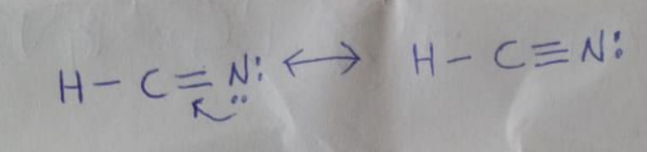

- Draw lewis structure for the following:
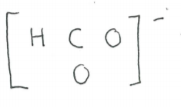
Solution
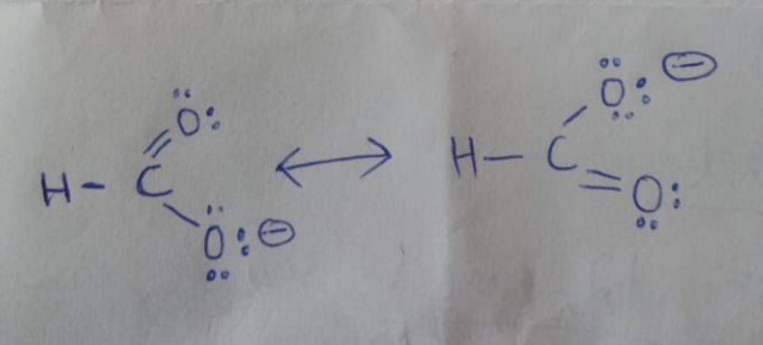

- Circle the substances that you expect to conduct electricity:
K₂CrO_{4(aq)} Cu_{(s)} Ba(OH)_{2(s)} HNO_{3(aq)}

Solution
K₂CrO_{4(aq)}
Cu_{(s)}
HNO_{3(aq)}

- For each molecule, name the strongest intermolecular force: (London dispersion, dipole-dipole or hydrogen bonding)
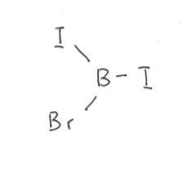London dispersion forces

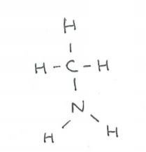Hydrogen Bonding

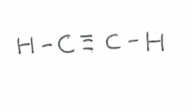Dipole-dipole
- What is the [k⁺] formed when 3.75 g of K₂CrO₄ is dissolved and diluted to 0.800 L?
Solution
Molecular weight of K₂CrO₄ is 194.1896
Moles of K₂CrO₄ = Mass (g) K₂CrO₄/Molar weight K₂CrO₄
3.75 g /194.1896= 0.0193 moles K₂CrO₄
Volume of solution=800 mL
Molarity of K₂CrO₄ = (No. of moles K₂CrO₄/Volume) X 1000
(0.0193/800) X 1000
Molarity is 0.024M

